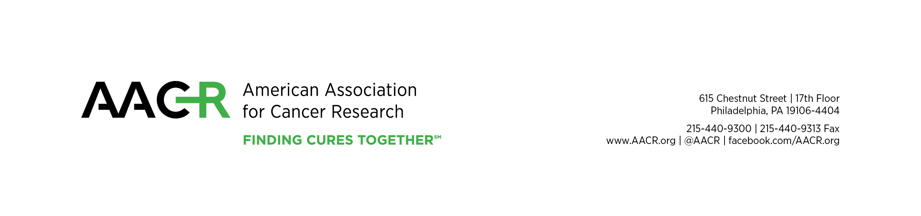

Advocate Verification Form

Thank you for your interest in attending an AACR meeting. Please complete and submit this form along with the registration form to the meeting you wish to attend. You will only be approved at the advocate rate if you are an advocate. Registration forms submitted without full payment cannot be processed and will be returned. Advocate registration is not available online. All fees must be paid in U.S. currency drawn on a U.S. bank. All registrations are for the entire meeting, partial registrations are not available.

I am an advocate affiliate member of AACR. My membership ID number is:
I am not an advocate affiliate member of AACR.
Please specify the meeting you would like to attend:

Name:
Title:
Mailing address:
 | City | State/Country |  | ZIP/Postal Code
Phone (direct line):
E-mail:

Organization name:
Mailing address:
 | City | State/Country |  | ZIP/Postal Code
Phone:
Website:
Executive director:

Please provide a brief description of your organization.

Please provide a narrative biographical sketch of 200–300 words describing your academic, professional or other relevant experiences, accomplishments within your organization, and current and past involvement with cancer-related advocacy and issues.

What are your current advocacy priorities and plans for the coming year?

IMPORTANT: Please type on the application form. The application is a Microsoft Word document that contains fields where you can type your replies right on the document. You can open and type on this document using Microsoft Word. Then, please save the completed application on your computer and e-mail a copy to advocacy@aacr.org.

If you have any difficulties opening or typing on the form, please email advoacy@aacr.org.

Please submit materials to:
Karen Russell Mills, Survivor and Patient Advocacy Program
American Association for Cancer Research
Phone: 215-446-7104, Fax: 215-446-7262
E-mail: Advocacy@aacr.org

