Project Livin’ Label Speaker Biographies
Episode 1 – Tucatinib: The Backstory

Sandra Weaver, Patient
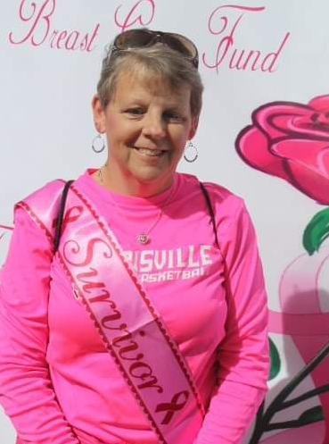
Sandra Weaver was diagnosed with breast cancer in October 2014. In 2015, the cancer spread to her lymph nodes resulting in a diagnosis of metastatic breast cancer. She went to Dana Farber for a second opinion and was fortunate to get into a drug study for her cancer. Three years later, she has had amazing results and the drug being studied was approved. She is able to get treatment locally and has chosen to stay in the study in the hope of continuing to contribute important data to the study.

Nancy Lin, MD, Dana-Farber Cancer Institute
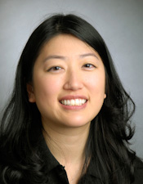
Nancy Lin, MD is the Associate Chief, Division of Breast Oncology and Director of the Metastatic Breast Cancer Program at Dana-Farber Cancer Institute and an Associate Professor of Medicine at Harvard Medical School. Her research is focused upon developing novel therapies for patients with metastatic breast cancer and in understanding mechanisms of therapeutic resistance.

Dr. Lin received her undergraduate degree from Stanford University and medical degree from Harvard Medical School. She subsequently completed her residency in Internal Medicine at Brigham and Women’s Hospital and fellowships in hematology and medical oncology at Dana-Farber Cancer Institute.

She has led multiple trials of novel systemic approaches for metastatic breast cancer, including patients with breast cancer brain metastases. She has had national and international leadership roles, including serving as the overall PI of several multi-center studies, co-chair of the Response Assessment in Neuro-Oncology metastatic working group, Chair of the Friends of Cancer-American Society Modernizing Eligibility Criteria Project-Brain Metastasis Working Group, and membership in national and international guidelines committees for the management of metastatic breast cancer.

Dr. Lin is also experienced in tissue- and blood-based translational research, and with the construction and analysis of clinical databases. She is the PI of the breast oncology-specific tissue banking protocol at Dana-Farber, Co-Chair of the Dana-Farber/Harvard Clinical Data and Tissue Users’ Committee, and PI of active protocols allowing prospective consent for research biopsies with linked clinical data across all stages of breast cancer, and of the EMBRACE (Ending Metastatic Breast Cancer for Everyone) metastatic cohort study. She serves as the DF/HCC institutional PI for the Translational Breast Cancer Research Consortium.

Ulrich-Peter Rohr, MD, PhD, Swissmedic

Prof. Dr Rohr is a professor and lecturer for Internal Medicine focusing on Hematology & Oncology at the University of Freiburg, Germany, since 2006 and has led- or co-authored numerous peer reviewed and invited publications. As a Medical Hematologist and Oncologist he is a member of the American Society of Clinical Oncology (ASCO), the European Society for Clinical Oncology (ESMO).
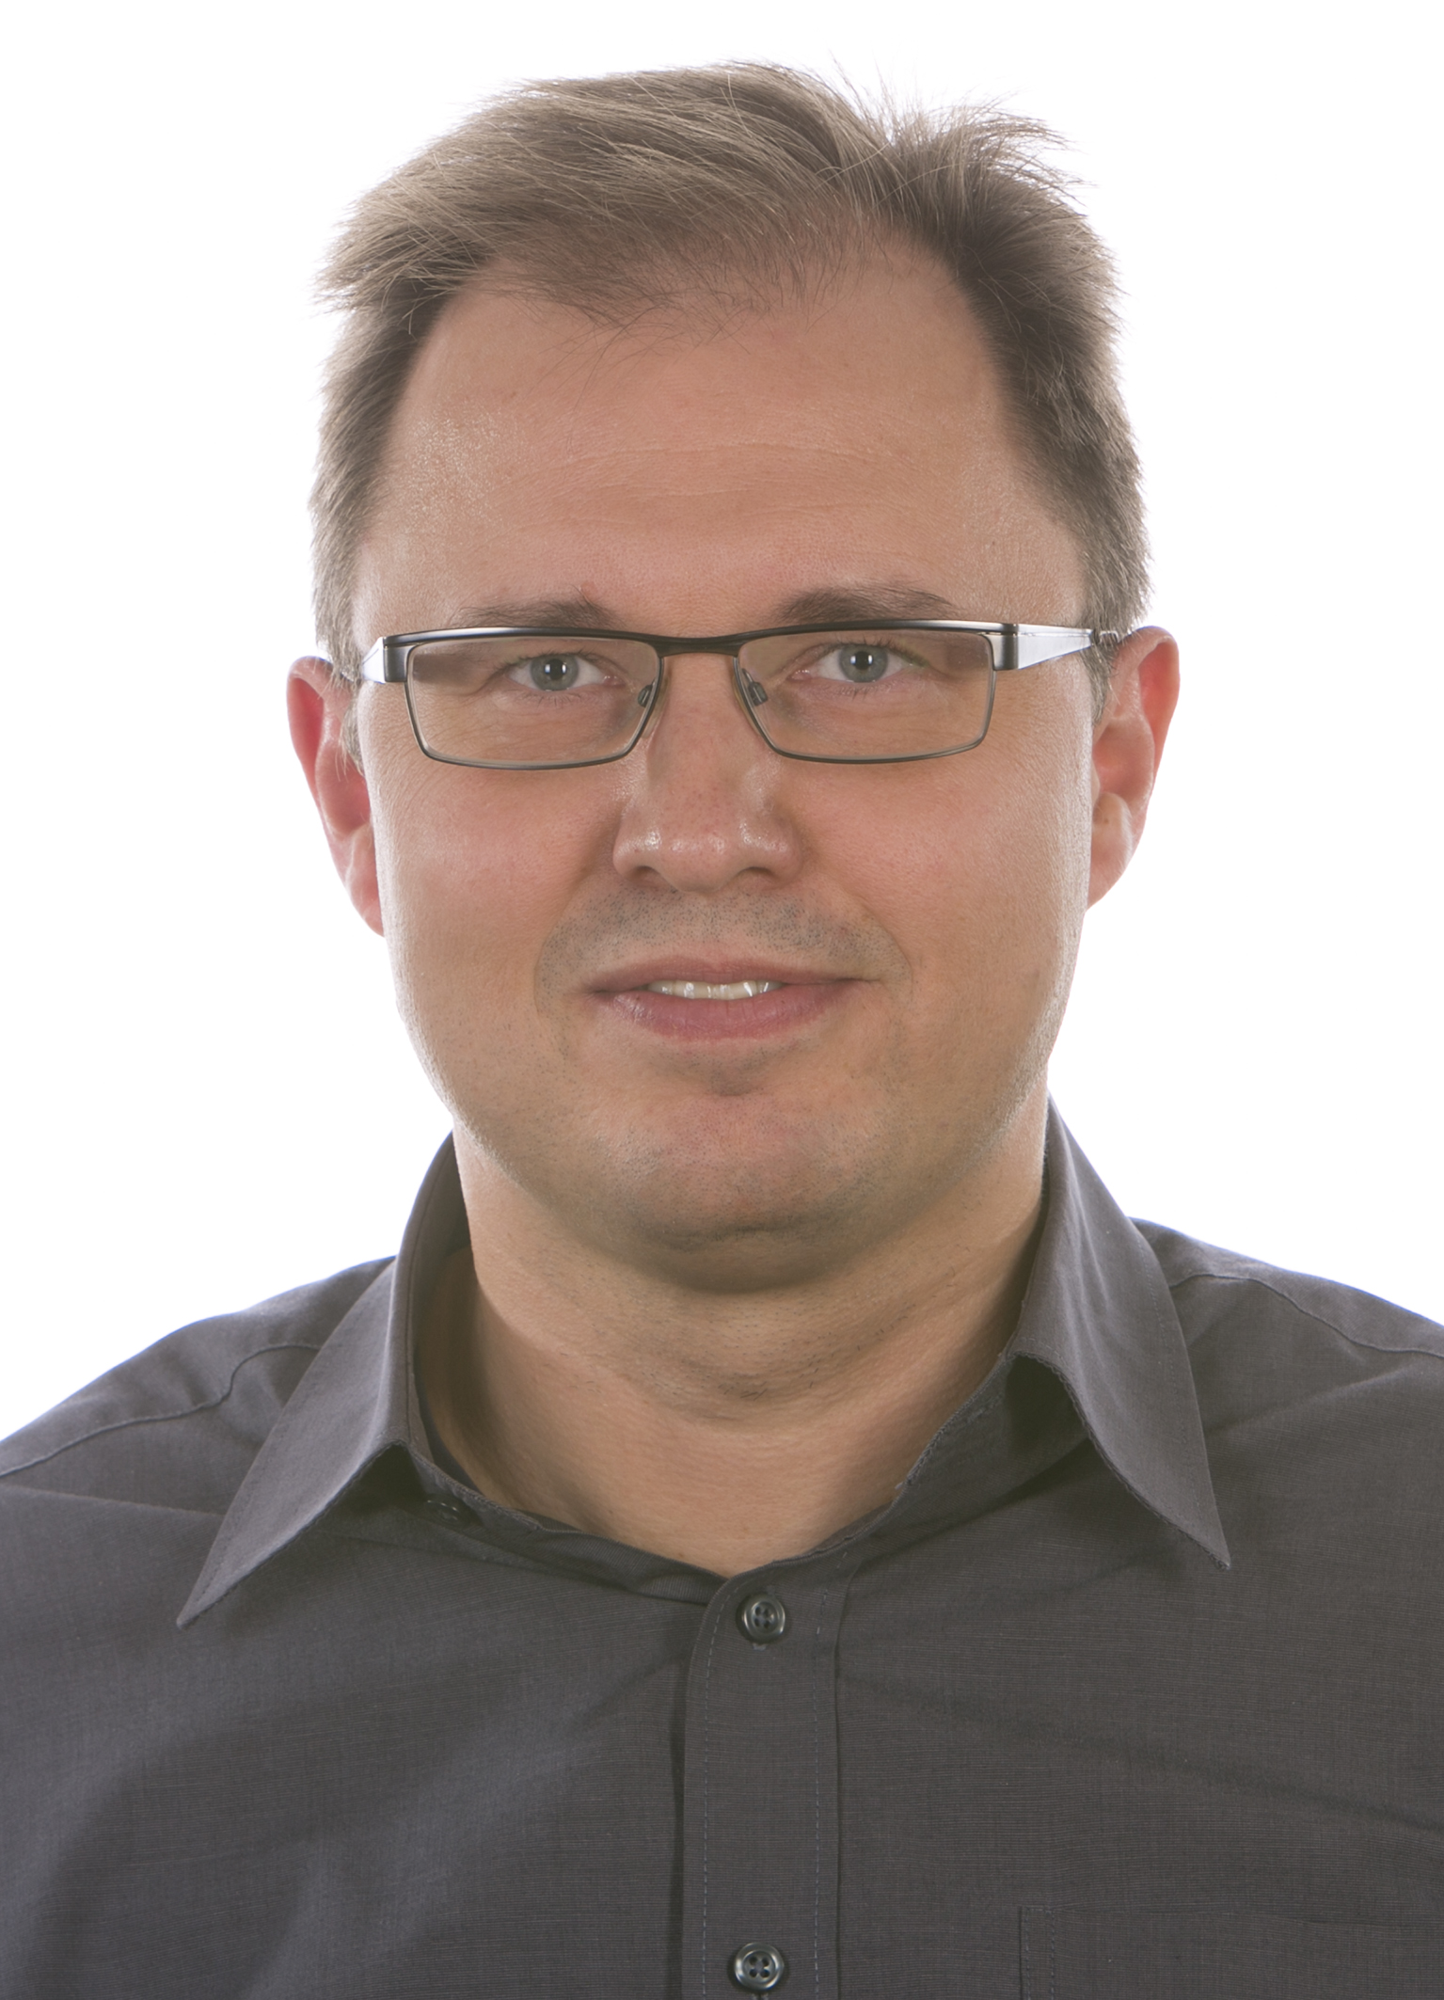

Prof. Dr. Rohr received his medical degree from the Justus-Liebig University in Giessen, Germany, before joining the University of Heidelberg (Germany) Medical Clinic in 1996, first as a second-year resident, then as Resident in Haematology and Oncology. During this period, he was also a post-doc research assistant at the German Cancer Research Center in Heidelberg/ Germany in therapeutic gene transfer continued his academic career in the Clinic for Haematology, Oncology and Immunology at the University of Düsseldorf, Germany until 2006.

Next to his academic career Dr. Rohr started to work at Roche, Basel Switzerland in Global Drug Development in 2007 and has been assuming the position Global Head of the Medical and Scientific Affairs of Roche Diagnostics Division since April 2009. In 2014, Dr. Rohr also took on the position Head of the Biomarkers of Roche Diagnostics. In these roles, his key focus is on the development and implementation of the Medical Value Strategy including companion diagnostics. In 2014, he received the German Felix Burda Award for best prevention idea in colon cancer.

In 2015 he took on a position as the Chief Medical Officer for Roche Sequencing Solution in Pleasanton, California, USA responsible for the development of prognostic and predictive assays in various disease areas with focus on oncology.

In 2017, returning to Europe he joined Swissmedic, the Swiss national authorisation and supervisory authority for drugs and medical products in Bern, Switzerland. At Swissmedic, he built a focussed clinical review unit for haematological & oncological products at Swissmedic's Authorisation Division. Since 9/2019 he was appointed to his recent role as Deputy Head of the Division Clinical Review & Head of Unit 2 Hematology & Oncology and continues his role as a professor and lecturer at the University of Freiburg, Germany.

Luke Walker, MD, Seattle Genetics
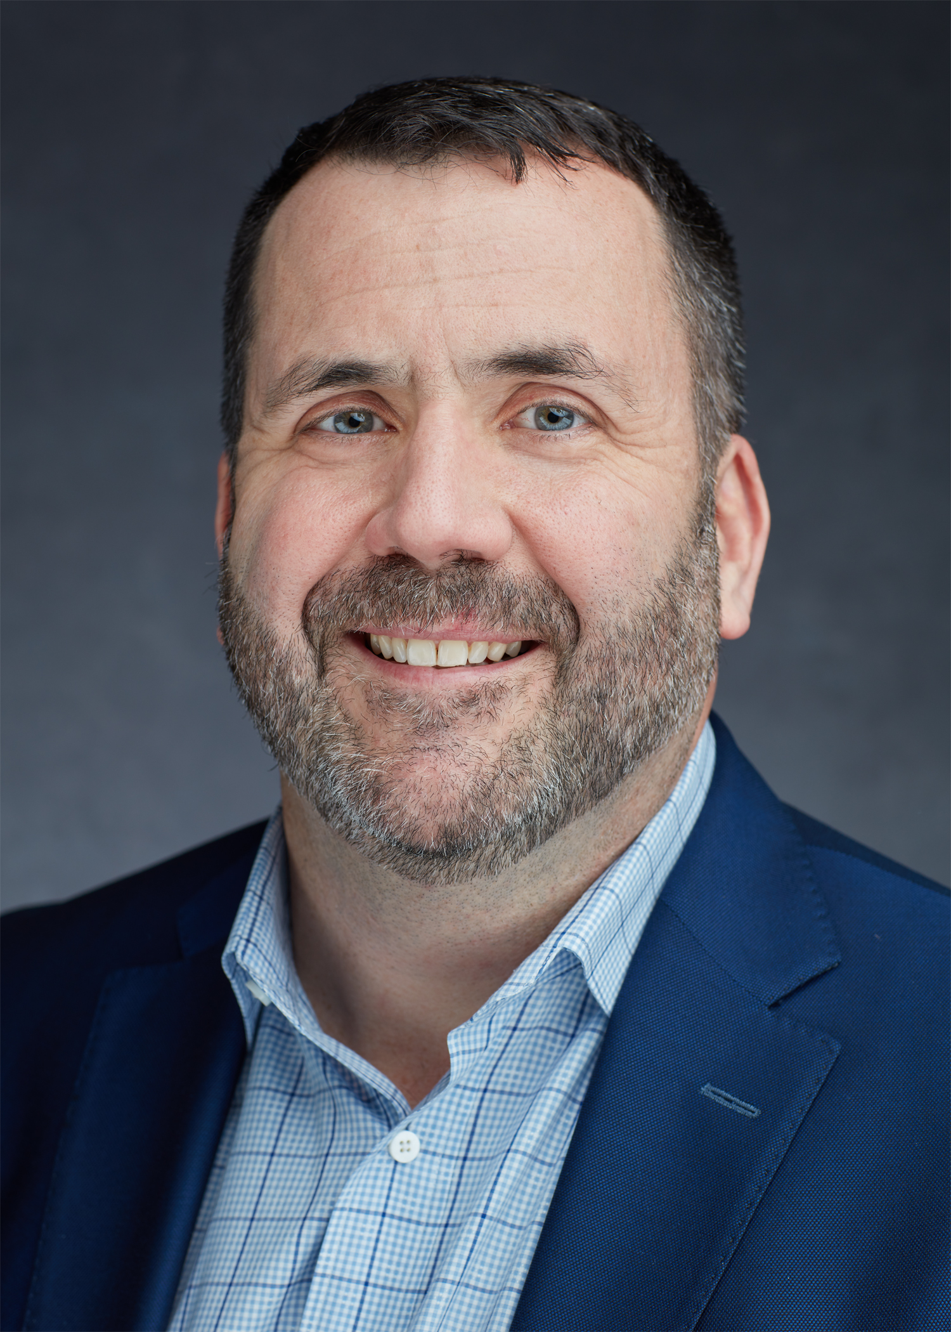
Dr. Walker is a medical oncologist who received his medical degree from the University of Oklahoma, followed by training in internal medicine, hematology/oncology, and hematopoietic stem cell transplant at Oregon Health Sciences University. He was a practicing hematologist and oncologist in the community for several years in Seattle, where he led a multidisciplinary Thoracic Oncology Clinic and Anticoagulation Clinic before joining Oncothyreon as Medical Director in Seattle in 2011. He began work on the tucatinib program in 2013, where he worked on designing early tucatinib clinical trials. He continued to lead the tucatinib program as Senior Vice President at Cascadian Therapeutics until 2018, working on the development of the HER2CLIMB pivotal clinical trial, which supported the approval of TUKYSA (tucatinib). He now continues on the tucatinib program with Seattle Genetics as Vice President of Clinical Development and Global Development Lead for TUKYSA.

Suparna Wedam, MD, U.S. Food and Drug Administration

Dr. Suparna Wedam is a Medical Officer and Breast Cancer Scientific Liaison at the U.S. Food and Drug Administration, Center for Drug Evaluation and Research, Office of Oncologic Drugs. Dr. Wedam graduated magna cum laude from Northwestern University with a B.A. in economics and then earned her medical degree from Georgetown University with election to the Alpha Omega Alpha Honor Society. She completed her internal medicine residency at Georgetown University Medical Center, where she was also a chief medical resident. Subsequently, she completed her medical oncology and hematology fellowship at the National Cancer Institute (NCI) in Bethesda, Maryland. Dr. Wedam remains clinically active, treating breast cancer patients at Walter Reed National Military Medical Center in Bethesda, Maryland.
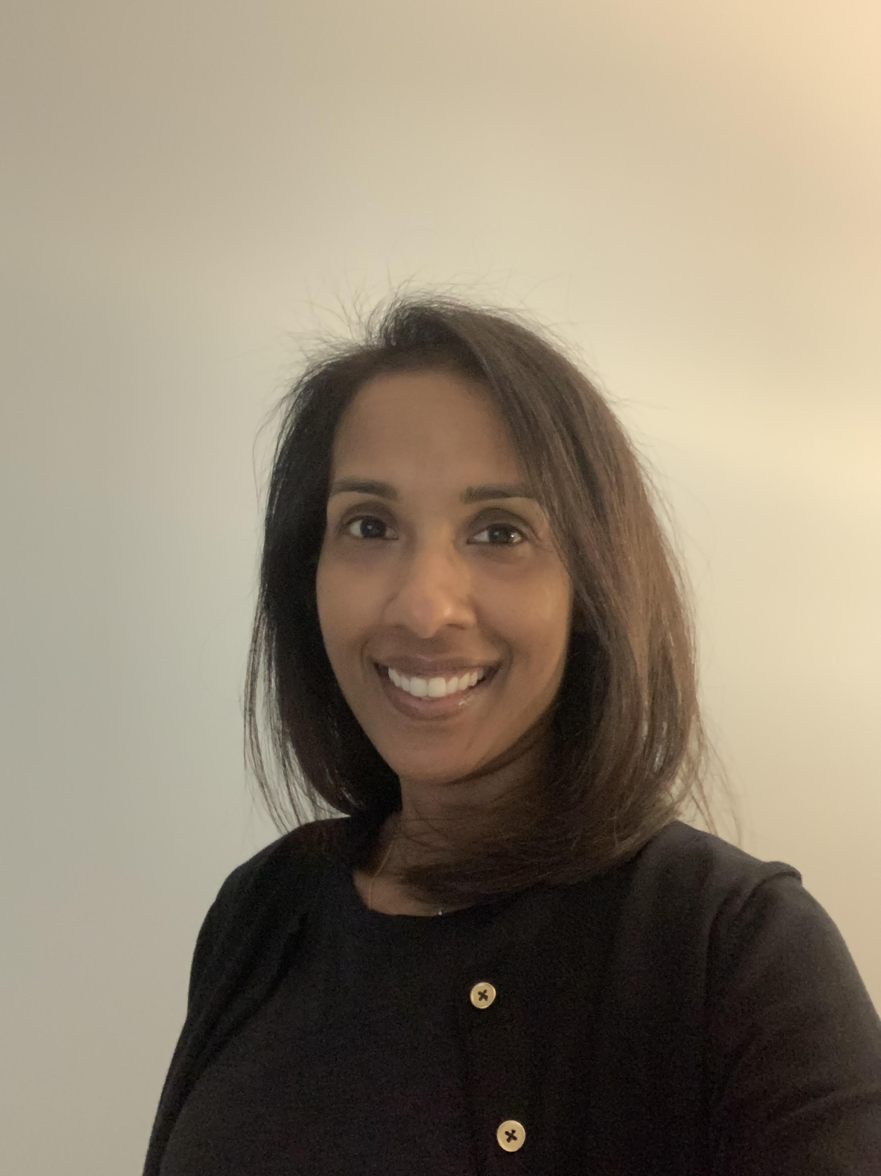
Richard Pazdur, MD, U.S. Food and Drug Administration
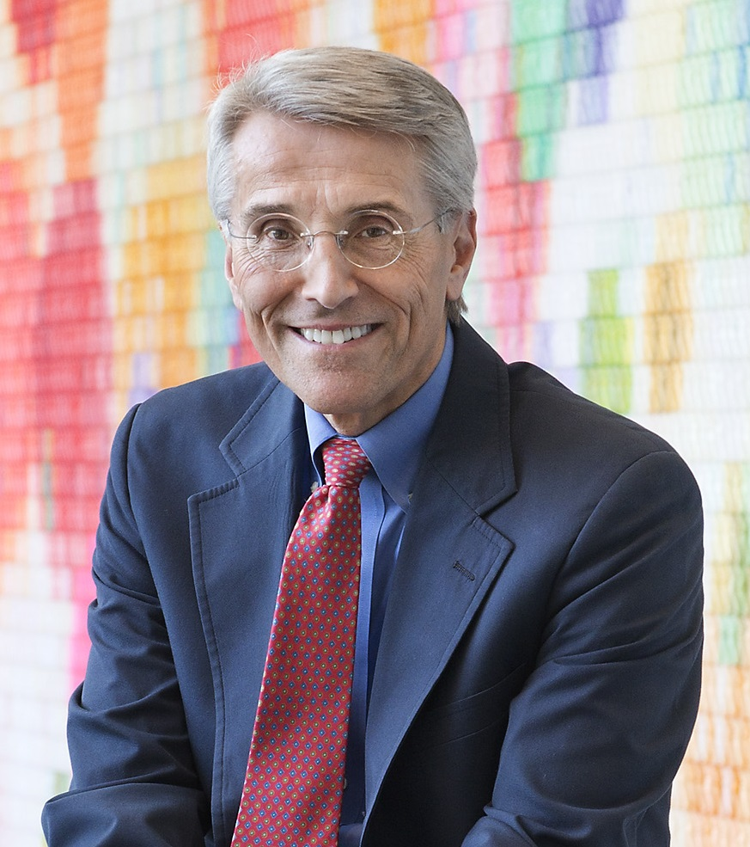
Richard Pazdur, MD, is director of the FDA Oncology Center of Excellence, which leverages the combined skills of FDA’s scientists and reviewers with expertise in drugs, biologics, and devices to expedite the development of novel cancer products.

Prior to joining FDA in 1999, Dr. Pazdur was professor of medicine at The University of Texas M.D. Anderson Cancer Center. From 1982 to 1988, he served on the faculty of Wayne State University. He received his bachelor’s degree from Northwestern University, his MD from Loyola Stritch School of Medicine, and completed clinical training at Rush-Presbyterian St. Luke’s Medical Center and University of Chicago Hospitals and Clinics.

Dr. Pazdur has published more than 600 articles, book chapters, and abstracts, and received many awards, including recognition in Fortune magazine’s 2015 list of “50 World’s Greatest Leaders,” the Massachusetts General Hospital Cancer Center’s “The One Hundred” list in 2016, and one of “The Bloomberg 50” in 2017.

