Project Livin’ Label Speaker Biographies
Episode 2 – Pemigatinib: The Backstory

Andrea Parrella, Patient

Andrea Parrella is an educator, writer, and patient advocate who has been living with unresectable stage IV Intrahepatic Cholangiocarcinoma since April of 2016. After one year of cisplatin and gemcitabine followed by localized radiation (y90), her community oncologist's treatment toolbox was empty. With his assistance, she made the decision to enroll in the phase II FGFR2 targeted pemigatinib clinical trial at the Mayo Clinic in Phoenix in June of 2017 and remained on the trial with stable disease for close to 3 years--just a few days shy of the FDA's announcement of the drug's approval. Andrea was devastated when she was removed from the trial due to the presence of a newly discovered lesion which was marked suspicious for metastasis-----so the unexpected announcement in late April of 2020 of the drug's early FDA approval was nothing less than life changing for her. Now Mitesh Borad, her clinician at the Mayo Clinic had the freedom to resume Andrea's treatment on pemigatinib. Now Andrea was free from the geographic constraints of the trial to move back to her hometown of Boston, Massachusetts. With FDA approval, Lipika Goyal, Andrea's clinician at Mass General Hospital in Boston was free to schedule an intervention (SIRT) months later when further disease progression occurred, an intervention which destroyed the area of disease progression, or 'escapement' with a minimal amount of interruption to her regular pemigatinib dosing schedule. As of December 2020, Andrea reports that she's been on pemigatinib for a total 3 1/2 years and counting and intends to continue on this treatment as long as it continues to keep her cancer in "check" with manageable side effects or until a new treatment with the promise of a cure comes along. Through her volunteer work with The Cholangiocarcinoma Foundation, Andrea continues to mentor a number of patients as they sift through the ever-changing FGFR2 clinical trial treatment landscape. When pemigatinib obtained FDA approval, she started a closed Facebook forum for pemigatinib patients and their caregivers to share their experiences managing pemigatinib’s side effects and help each other navigate the complexities of obtaining insurance coverage for the high cost of the drug.

Tanios Bekaii-Saab, MD, FACP, Mayo Clinic
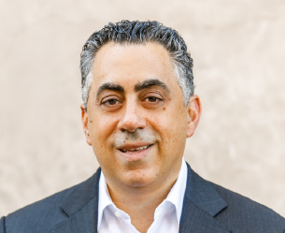
Tanios Bekaii-Saab, MD, FACP is a Professor of Medicine at the Mayo Clinic College of Medicine and Science, Leader of the Gastrointestinal Cancer Program at the Mayo Clinic Cancer Center, Medical Director of the Cancer Clinical Research Office, Vice Chair and Section Chief for Medical Oncology for the Division of Hematology/Oncology in the Department of Internal Medicine at the Mayo Clinic in Phoenix, Arizona, USA. He is also the consortium chair for the ACCRU research Network and the clinical research co-lead for the MCCC transformation leadership team for the Mayo Enterprise. Additionally, Dr. Bekaii-Saab is the Mayo Clinic member for the NCCN Guidelines Steering Committee. Dr. Bekaii-Saab is currently the co-leader of the Hepatobiliary Cancer Sub-Committee of the Alliance for Clinical Trials in Oncology and the Vice-Chair for the National Cancer Institute’s Hepatobiliary Task Force. He is also a member of the ASCO Scientific Program Committee for Colorectal and Anal Cancers.

Dr. Bekaii-Saab earned his medical degree from the American University of Beirut in Lebanon and completed a residency in internal medicine at Indiana University Medical Center in Indianapolis, Indiana, USA. He then completed fellowships in clinical pharmacology and experimental therapeutics and hematology/oncology at Tufts University/New England Medical Center in Boston, Massachusetts, USA.

Dr. Bekaii-Saab, MD, conducts clinical and translational research focused on developing anticancer agents for patients with gastrointestinal cancers. Dr. Bekaii-Saab collaborates extensively with various scientists and industry partners to design and execute innovative clinical trials, including many first-in-human studies. Bekaii-Saab’s research includes a large focus on the incorporation of agents that target the multiple facets of cancer, including genetic and epigenetic drivers, as well as the feeding microenvironment and the immune milieu. His work includes two recent discoveries as co-inventor of a molecule that targets cancer-related cachexia (AR-42) and an anti-PD-1 vaccine (PD-Vaxx), which has resulted in licensing opportunities (under patents: US6387883B1, EP3600389A1, WO2019055687A1, ES2729619T3 and others). AR42 was licensed to Recursion. PD-Vaxx was licensed to imugene and is undergoing clinical development in with the recent launch of IMU-201-101_"B-Cell Immunotherapy, in Adults with Non-Small Cell Lung Cancer". Additionally, Dr. Bekaii-Saab’s research has also led to the launch of a number of phase II and III clinical trials, including but not limited to a recent trial with a cancer stem cell inhibitor in pancreatic cancer, the development of an FGFR inhibitor in bile duct cancers, and a contribution to the pivotal study that led to the regulatory approval of nanoliposomal irinotecan for treating pancreatic cancer.

Dr. Bekaii-Saab served as a reviewer for many high impact journals and sits on the editorial board of the prestigious Journal of the National Cancer Institute. Dr. Bekaii-Saab has authored or co-authored more than 350 peer reviewed publications, abstracts, and book chapters, including papers in such journals as Lancet, Lancet Oncology, Journal of Clinical Oncology, JAMA, Journal of the National Cancer Institute, Annals of Oncology, and Clinical Cancer Research.

Lola A. Fashoyin-Aje, MD, MPH, U.S. Food and Drug Administration

Lola A. Fashoyin-Aje, MD, MPH, is a medical oncologist and Deputy Division Director in the Division of Oncology 3 (DO3) in the Office of Oncologic Diseases (OOD) at the Food and Drug Administration (FDA). She also serves as the Oncology Center of Excellence (OCE) Associate Director for Science and Policy to Address Health Disparities.

At the FDA, Dr. Fashoyin-Aje has served as clinical reviewer in the Gastrointestinal (GI) Malignancies team, and as team leader for the Breast Malignancies, Melanoma and Sarcoma, and GI clinical teams. In her current roles, she provides scientific and policy guidance and oversight to multidisciplinary teams reviewing and approving drugs and biologics for the treatment of solid tumor (GI, sarcoma, melanoma) malignancies, and leads the OCE’s efforts to improve inclusion of diverse demographic subgroups in clinical trials.

Prior to joining the FDA, Dr. Fashoyin-Aje completed her residency in internal medicine and fellowship in medical oncology at Johns Hopkins. She completed her undergraduate and graduate training at Columbia University and Yale University, respectively, and earned her medical degree from the University of Rochester.

Peter Langmuir, MD, Incyte
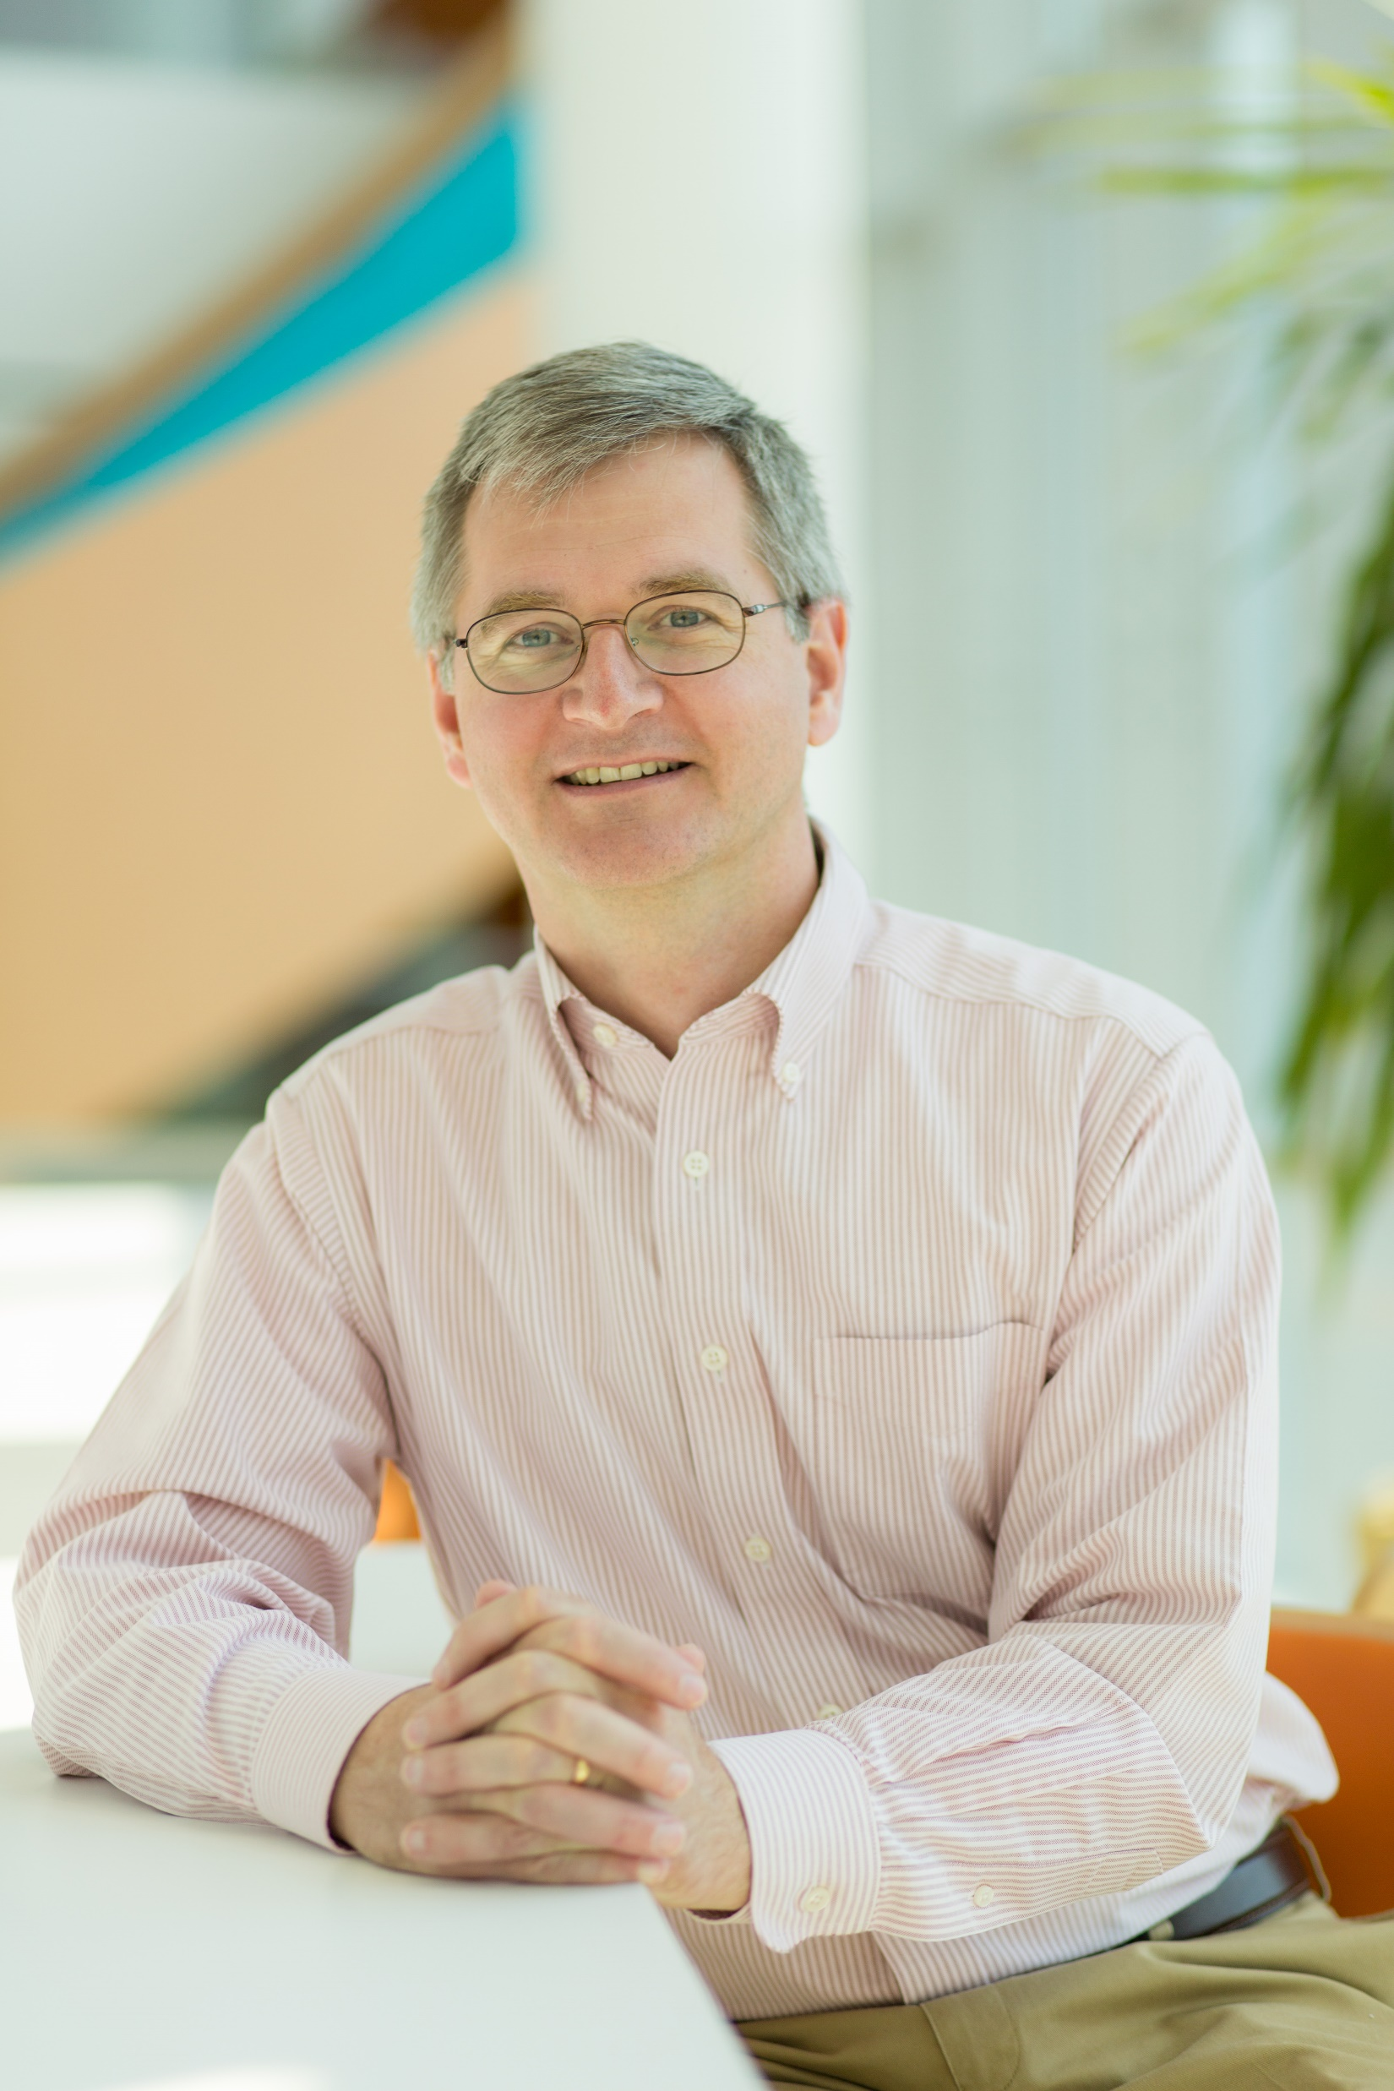
Peter Langmuir, MD is Group VP of Oncology Targeted Therapeutics at Incyte. He gained his medical degree at the Yale University School of Medicine and trained in pediatrics and pediatric hematology-oncology at The Children’s Hospital of Philadelphia. He has worked in the pharmaceutical and biotech industry for the past 18 years, focusing primarily on the clinical development of targeted therapies for both solid tumors and hematologic malignancies.

Stacie Lindsey, Cholangiocarcinoma Foundation

Stacie Lindsey is the CEO and Founder of the Cholangiocarcinoma Foundation (CCF), a global non-profit organization whose mission is to find a cure and improve the quality of life for those affected by cholangiocarcinoma (bile duct cancer). Her efforts focus on increasing knowledge and understanding about key issues central to etiology, prevention, early detection, treatment, prognosis, and cure of cholangiocarcinoma through advocacy, education, collaboration, and research. More information can be found at www.cholangiocarcinoma.org.
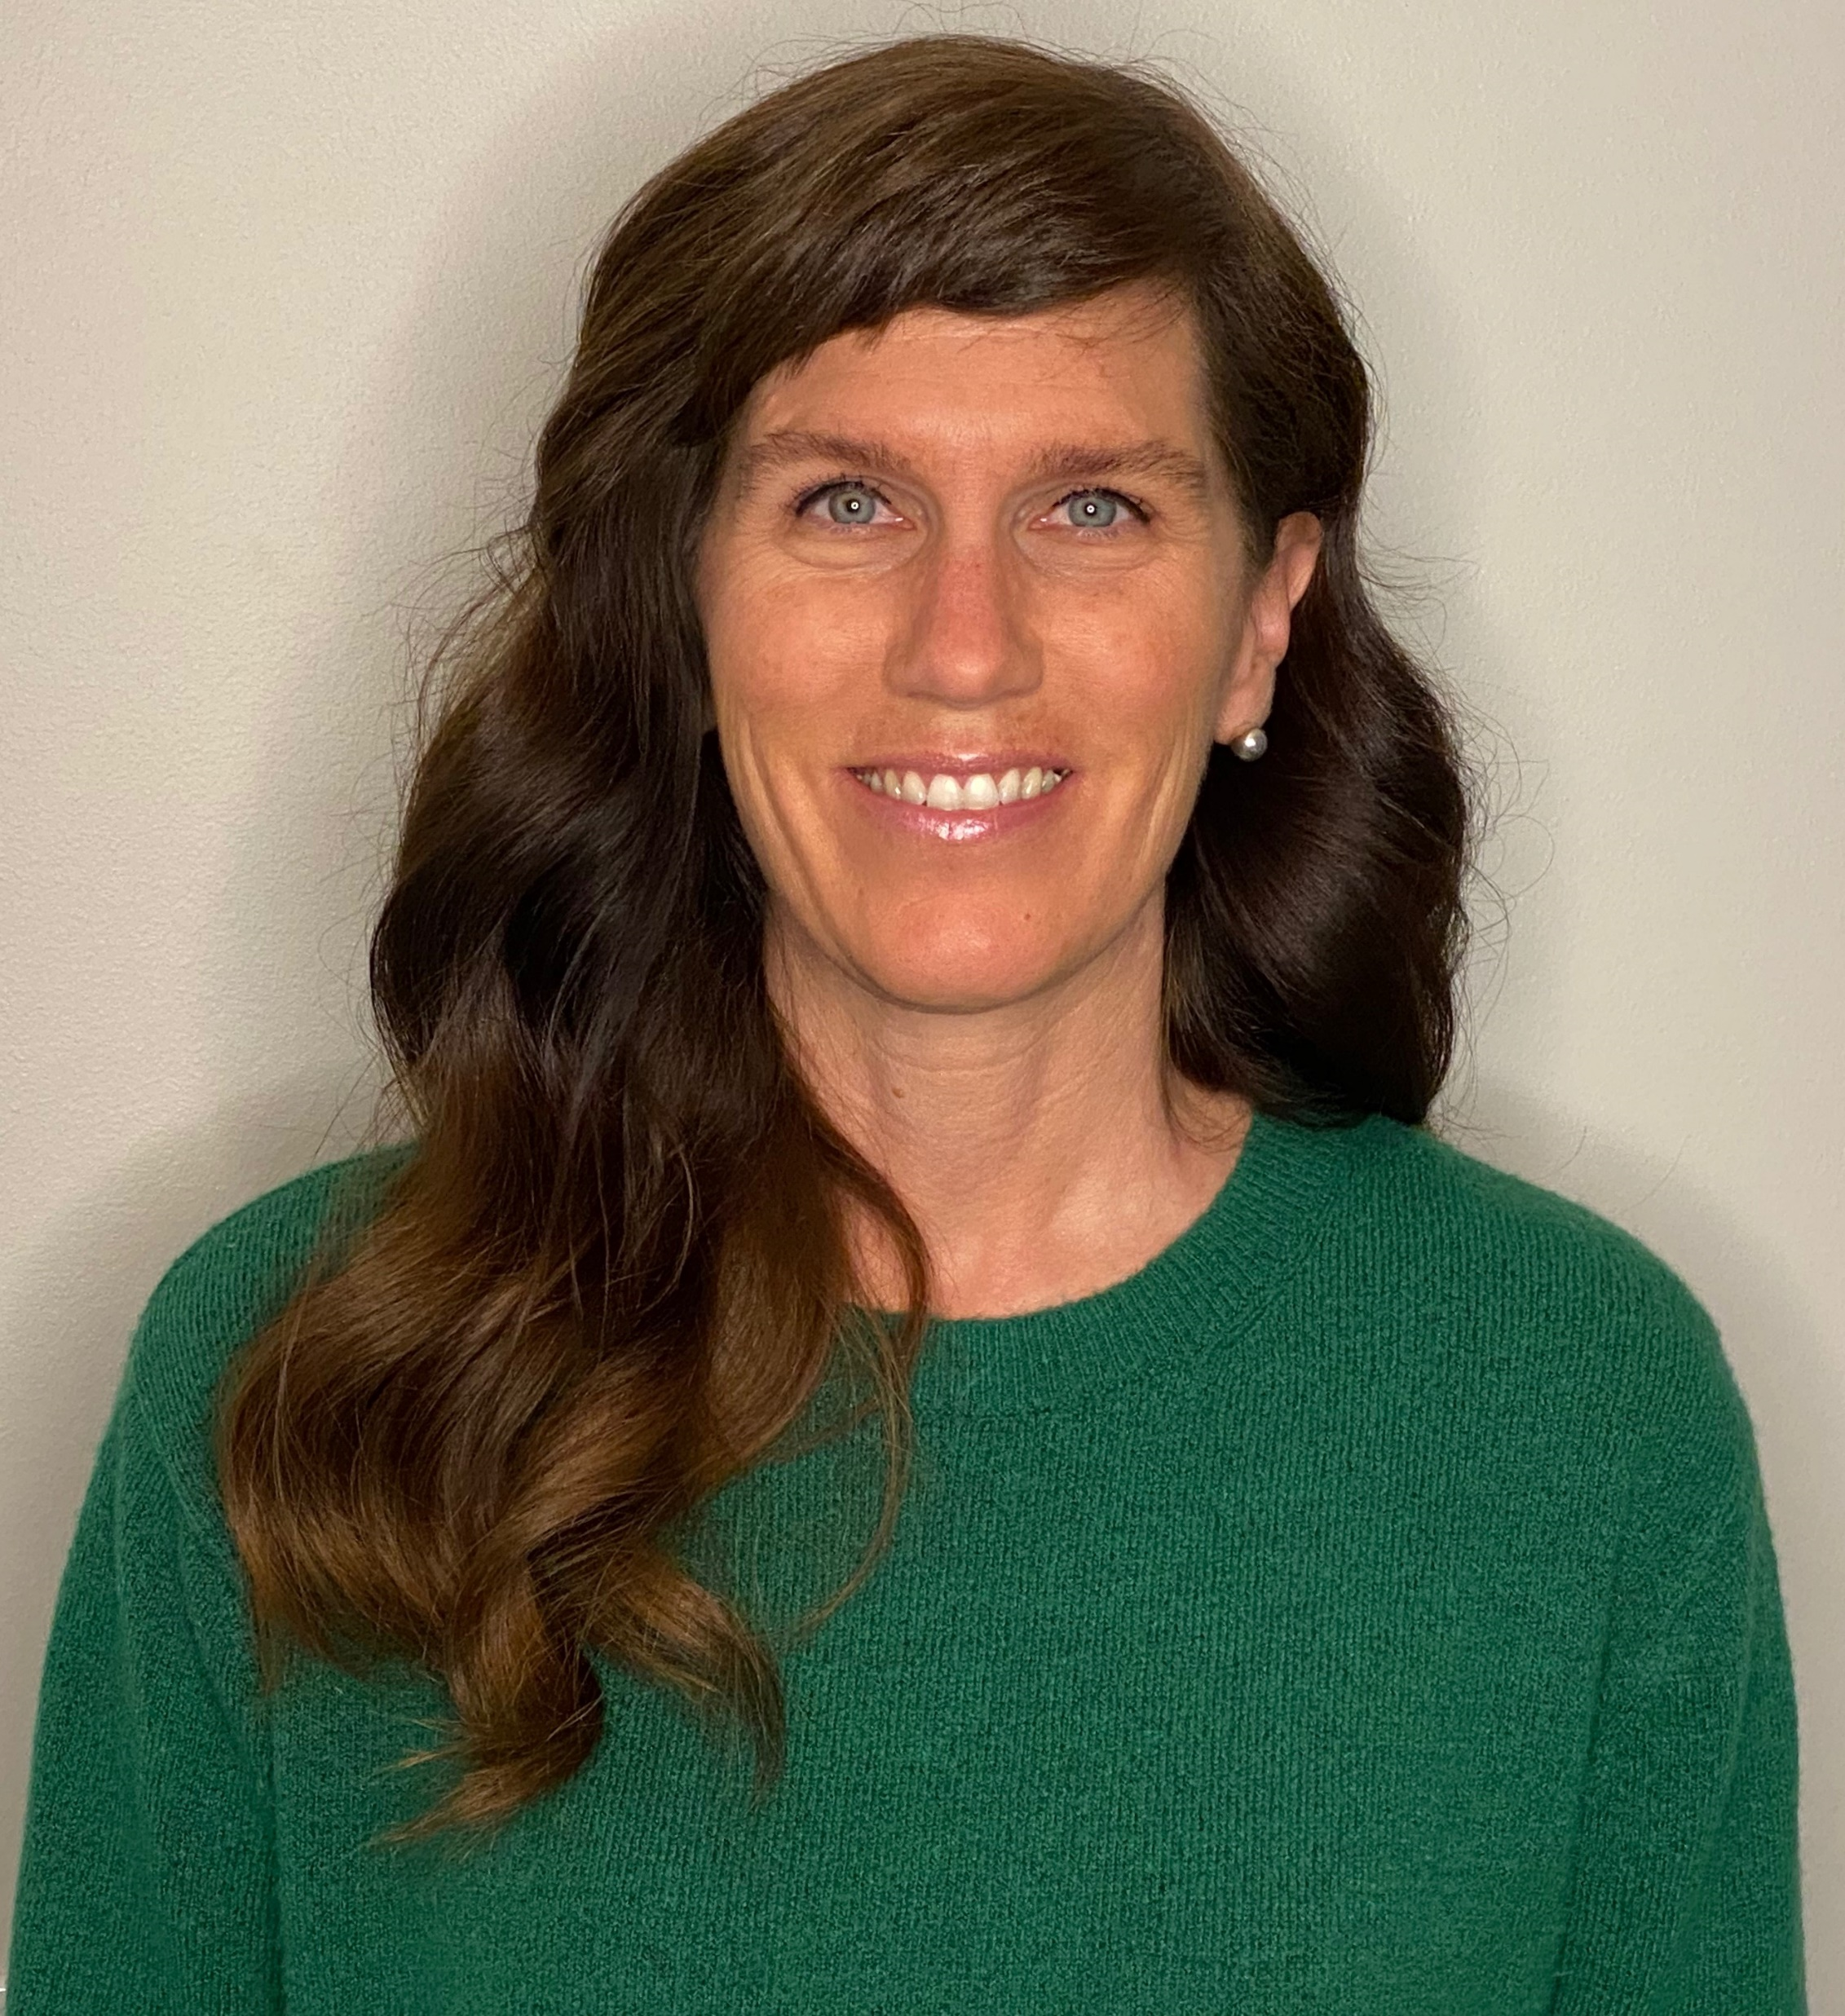

Since 2006, she has engaged with members of the scientific, medical and academic communities; policymakers and regulators, industry, advocates, patients and caregivers to advance scientific research by strengthening and supporting global collaborations; nurturing a dedicated team of young investigators; inspiring innovation; and advocating for those affected by this rare and aggressive form of cancer.

Since 2015, she has served as a Founding Member of the International Cholangiocarcinoma Research Network (ICRN), which is a global consortium of research groups working in concert to accelerate scientific and medical progress on an international level, expedite delivery of innovative care and treatments, and improve health outcomes for patients. She currently serves as an Executive Committee Member for the GI Cancers Alliance, and as an advocate for the Hepatobiliary SPORE’s at both Mayo Clinic and MGH.

Richard Pazdur, MD, U.S. Food and Drug Administration
Richard Pazdur, MD, is director of the FDA Oncology Center of Excellence, which leverages the combined skills of FDA’s scientists and reviewers with expertise in drugs, biologics, and devices to expedite the development of novel cancer products.

Prior to joining FDA in 1999, Dr. Pazdur was professor of medicine at The University of Texas M.D. Anderson Cancer Center. From 1982 to 1988, he served on the faculty of Wayne State University. He received his bachelor’s degree from Northwestern University, his MD from Loyola Stritch School of Medicine, and completed clinical training at Rush-Presbyterian St. Luke’s Medical Center and University of Chicago Hospitals and Clinics.

Dr. Pazdur has published more than 600 articles, book chapters, and abstracts, and received many awards, including recognition in Fortune magazine’s 2015 list of “50 World’s Greatest Leaders,” the Massachusetts General Hospital Cancer Center’s “The One Hundred” list in 2016, and one of “The Bloomberg 50” in 2017.

