AACR Virtual Patient Advocate Forum

The evolution of FDA regulatory science

and its impact on cancer

TuesDAY, June 27, 2023

1:00-2:30 pM ET

1:00 pm Welcome and Opening remarks
Anna D. Barker, PhD, FAACR, Ellison Institute for Transformative Medicine

1:05 pm PAtient Advocate Perspective
Allison Rosen, MS, American Cancer Society

Live Q&A

1:15 pm Overview of the FDA Oncology Center of Excellence

Richard Pazdur, MD, Oncology Center of Excellence, FDA

Live Q&A

1:25 PM The Evolution of Regulatory science and drug discovery

and Development
David R. Parkinson, MD, ESSA Pharma, Inc.

Live Q&A

1:35 PM How the FDA and Multiple Myeloma communities

changed patient outcomes

Kenneth C. Anderson, MD, FAACR, Dana-Farber Cancer Institute
Live Q&A

1:45 PM Live Panel Discussion
Moderator
Anna Barker

Panelists
Kenneth Anderson
David Parkinson
Richard Pazdur
Allison Rosen
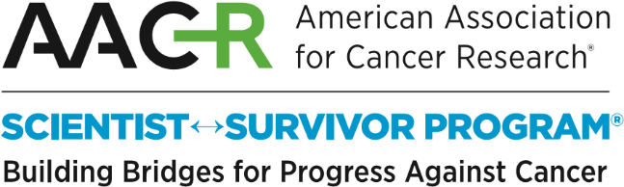
Join the conversation @AACR with #AACRForum

