

AACR Patient Advocate Forum

artificial intelligence in cancer research, Care, and Survivorship

TUESDAY, MARCH 24, 2026
3:30-5:00 PM ET

3:30 PM WELCOME AND OPENING REMARKS
Anna D. Barker, PhD, FAACR, Ellison Medical Institute, Los Angeles, CA

3:40 PM SPEAKER INTRODUCTIONS
Anna D. Barker, PhD, FAACR, Ellison Medical Institute, Los Angeles, CA
3:45 PM TOPIC OVERVIEW
Carlo C. Maley, PhD, Arizona State University, Tempe, AZ
George W. Sledge, Jr. MD, Caris Life Sciences, Palo Alto, CA
Alan Russell, PhD, Amgen, Thousand Oaks, CA
Saranne Rothberg, The Comedy Cures Foundation, Tenafly, NJ
4:05 PM PANEL DISCUSSION
Moderator
Anna Barker

Panelists
Carlo Maley Saranne Rothberg Alan Russell George Sledge

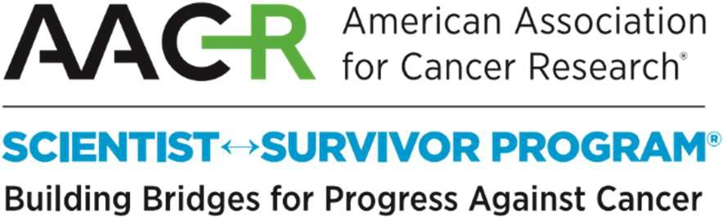
 Join the conversation @AACR with #AACRForum

